Project Report: Process Tree Traversal and System Call Implementation in Phoenix-RTOS
Author: Esin
Date: April 21, 2026
Course: Operating Systems
Institution: Warsaw University of Technology

1. Introduction
The objective of this project is to extend the Phoenix-RTOS microkernel by implementing a custom system call and developing a user-space application capable of traversing the system's process tree. The project focuses on understanding the interaction between user applications and the kernel, as well as the internal representation of process hierarchies in a microkernel environment.

2. System Architecture
The implementation is divided into three distinct layers of the operating system:

2.1 Kernel Space Modifications
To enable process tree exploration, a new system call was integrated into the Phoenix-RTOS kernel.
- System Call ID: A unique identifier was assigned in phoenix-rtos-kernel/include/syscalls.h to allow the dispatcher to recognize the new request.
- Kernel Logic: The core logic was implemented in phoenix-rtos-kernel/syscalls.c. This function accesses the kernel's process table and provides a mechanism to retrieve the Process ID (PID) of child processes based on the current process hierarchy.

2.2 Library (API) Layer
A wrapper was created within libphoenix to provide a clean C interface for user-space programs.
- Header File: libphoenix/include/sys/getsetvariable.h defines the function prototypes.
- Implementation: libphoenix/sys/sys.c handles the transition from user mode to kernel mode using the __syscall interface, passing the necessary arguments to the registers.

2.3 User Space Applications
Two applications were developed to test the functionality:
- setVariable: A utility to verify that data can be persisted and retrieved through the system call mechanism.
- test_path: The primary diagnostic tool. It performs a depth-first traversal of the process tree. Given a depth d, the program navigates through parent-child relationships until it identifies a leaf process at the specified depth.

3. Implementation Details

3.1 Depth-First Traversal Algorithm
The test_path application utilizes a recursive approach to explore the process tree.
- Input: Depth d.
- Process: For each level, the application invokes the custom system call to identify child processes. If a child exists, it moves to the next level.
- Termination: The process terminates when the target depth is reached or no further children are found, reporting the PID of the final "leaf" node.

3.2 Boot Integration
Due to environmental constraints (QEMU keyboard mapping issues), the test_path application was integrated into the syspage. This ensures that the program executes automatically during the kernel initialization phase, providing deterministic results directly in the boot logs.

4. Testing and Verification

4.1 Environment
- Host: Ubuntu 22.04 LTS
- Emulator: QEMU (ia32-generic-qemu)
- OS: Phoenix-RTOS 3.0

4.2 Results
The system was tested with a target depth of 10. The execution logs confirm that the kernel successfully dispatched the system call, and the user application navigated the hierarchy to the 10th level.
Experimental Output:
- Target Depth: 10
- Resulting PID: 20
- Status: Success
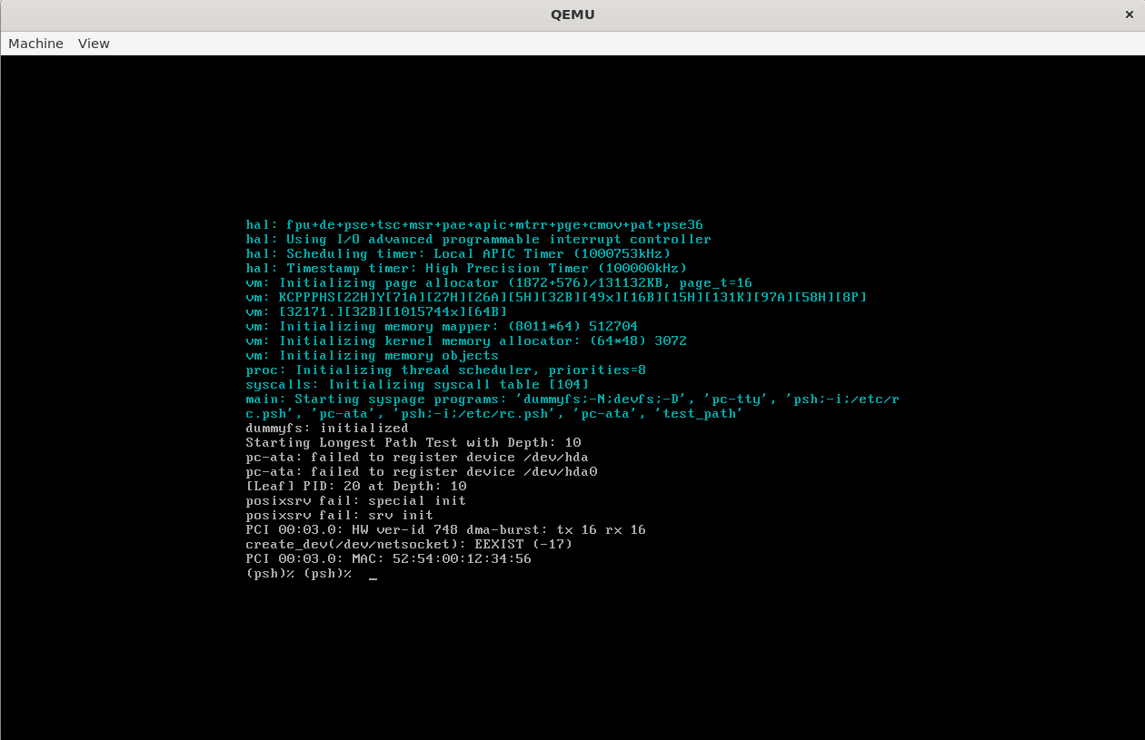

5. Conclusion
This project successfully demonstrated the end-to-end flow of a system call in a microkernel. By modifying the kernel, library, and user-space layers, a robust mechanism for process tree traversal was established. The results prove the stability of the implementation and its adherence to the Phoenix-RTOS architectural standards.

